The Model of Hydrometeorological centre of Russia Forecast
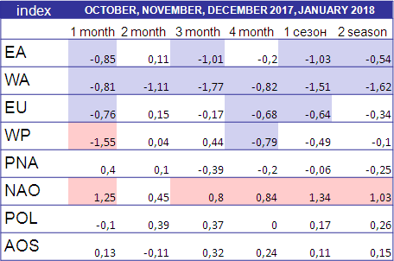Red (blue) represents the positive (negative) phase of index

Designation
- EA - East Atlantic Oscillation
- WA - West Atlantic Oscillation
- EU - Eurasia Pattern
- WP - West Pacific Oscillation
- PNA - Pacific – North American Pattern
- NAO - North Atlantic Oscillation
- POL - Polar Oscillation
- AOS - Arctic Oscillation

Quartile Analysis of Indices
