|  |  |  |  |
| --- | --- | --- | --- |
| C:\Users\Drugi\Desktop\GPS-ECMWF\April\Temperatura\GPC-ECMWF-Europe-ensemble-mean-T2m-JJA-01-04-2024.png |  | C:\Users\Drugi\Desktop\GPS-ECMWF\April\Temperatura\GPC-ECMWF-Europe-tercile-summary-T2m-JJA-01-04-2024.png | C:\Users\Drugi\Desktop\GPS-ECMWF\April\Temperatura\GPC-ECMWF-Europe-prob-for-highest-20-T2m-JJA-01-04-2024.png |
| C:\Users\Drugi\Desktop\April\Temperatura\GPC-ECMWF-Europe-ensemble-mean-T2m-JJA-01-04-2025.png |  | C:\Users\Drugi\Desktop\April\Temperatura\GPC-ECMWF-Europe-tercile-summary-T2m-JJA-01-04-2025.png | C:\Users\Drugi\Desktop\April\Temperatura\GPC-ECMWF-Europe-prob-for-highest-20-T2m-JJA-01-04-2025.png |

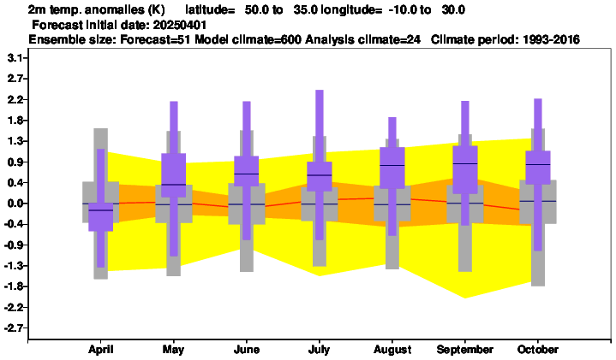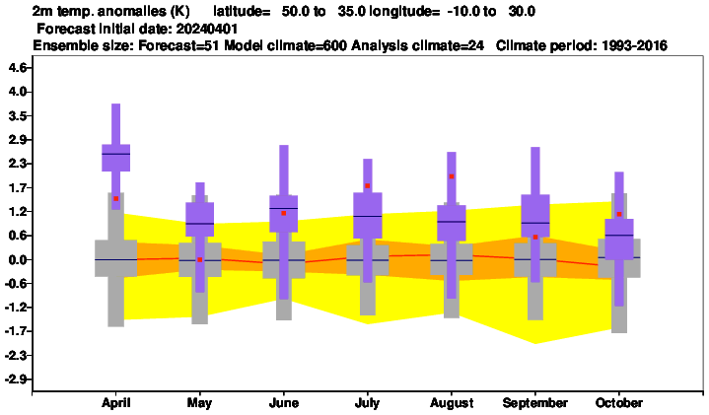

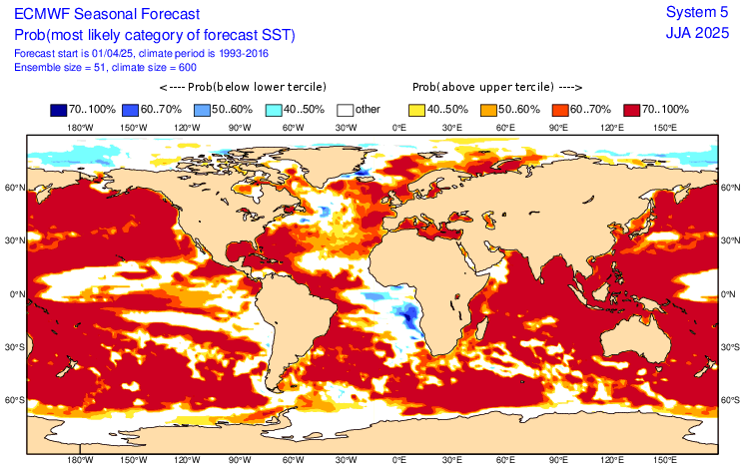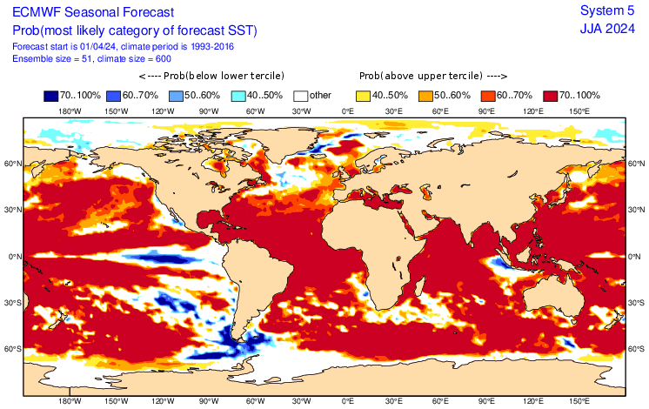

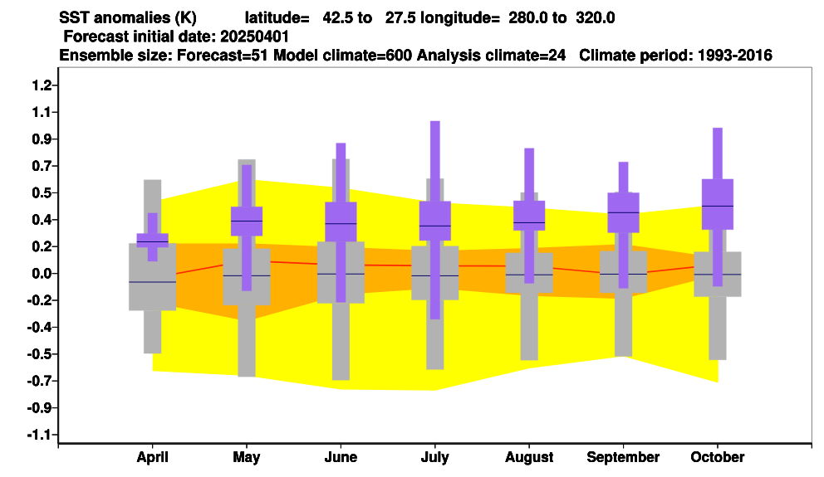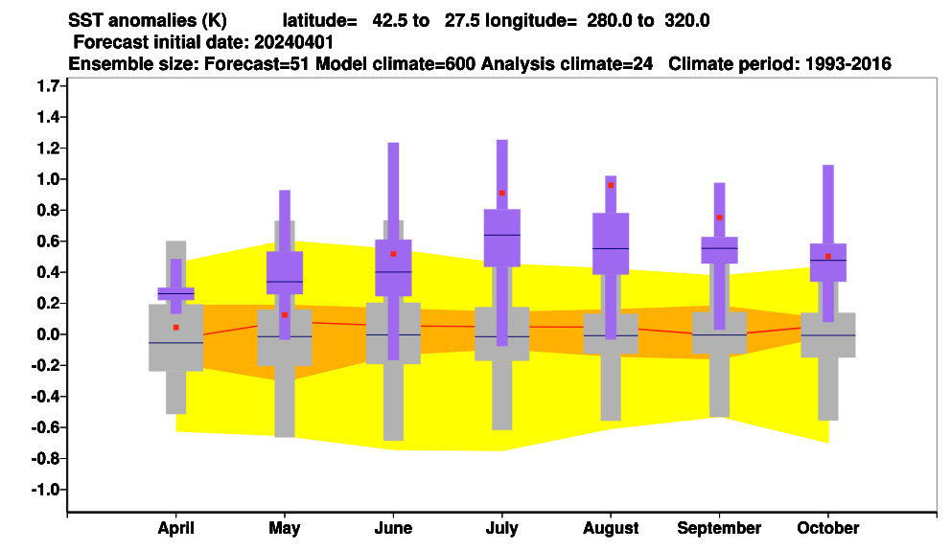

|  |  |  |  |
| --- | --- | --- | --- |
| C:\Users\Drugi\Desktop\GPS-ECMWF\April\Padavine\GPC-ECMWF-Europe-ensemble-mean-Precipitation-JJA- 01-04-2024.png | C:\Users\Drugi\Desktop\GPS-ECMWF\April\Padavine\GPC-ECMWF-Europe-prob-exceeding-median-Precipitation-JJA-01-04-2024.png | C:\Users\Drugi\Desktop\GPS-ECMWF\April\Padavine\GPC-ECMWF-Europe-tercile-summary-Precipitation-JJA-01-04-2024.png | C:\Users\Drugi\Desktop\GPS-ECMWF\April\Padavine\GPC-ECMWF-Europe-prob-for-lower-third-of-the-distribution-Precipitation-JJA-01-04-2024.png |
| C:\Users\Drugi\Desktop\April\Padavine\GPC-ECMWF-Europe-ensemble-mean-Precipitation-JJA- 01-04-2025.png | C:\Users\Drugi\Desktop\April\Padavine\GPC-ECMWF-Europe-prob-exceeding-median-Precipitation-JJA-01-04-2025.png | C:\Users\Drugi\Desktop\April\Padavine\GPC-ECMWF-Europe-tercile-summary-Precipitation-JJA-01-04-2025.png | C:\Users\Drugi\Desktop\April\Padavine\GPC-ECMWF-Europe-prob-for-lower-third-of-the-distribution-Precipitation-JJA-01-04-2025.png |