|  |  |  |  |
| --- | --- | --- | --- |
| C:\Users\Drugi\Desktop\GPS-ECMWF\April\Temperatura\GPC-ECMWF-Europe-ensemble-mean-T2m-JJA-01-04-2024.png |  | C:\Users\Drugi\Desktop\GPS-ECMWF\April\Temperatura\GPC-ECMWF-Europe-tercile-summary-T2m-JJA-01-04-2024.png | C:\Users\Drugi\Desktop\GPS-ECMWF\April\Temperatura\GPC-ECMWF-Europe-prob-for-highest-20-T2m-JJA-01-04-2024.png |
| C:\Users\Drugi\Desktop\April\Temperatura\GPC-ECMWF-Europe-ensemble-mean-T2m-JJA-01-04-2025.png |  | C:\Users\Drugi\Desktop\April\Temperatura\GPC-ECMWF-Europe-tercile-summary-T2m-JJA-01-04-2025.png | C:\Users\Drugi\Desktop\April\Temperatura\GPC-ECMWF-Europe-prob-for-highest-20-T2m-JJA-01-04-2025.png |

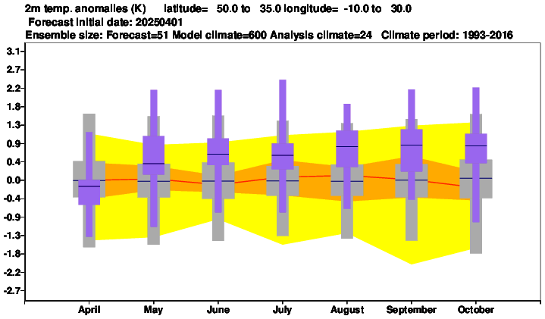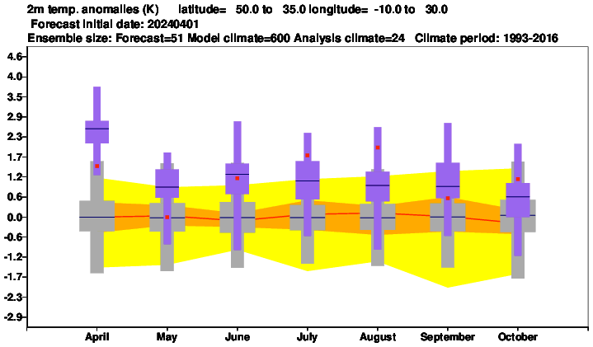

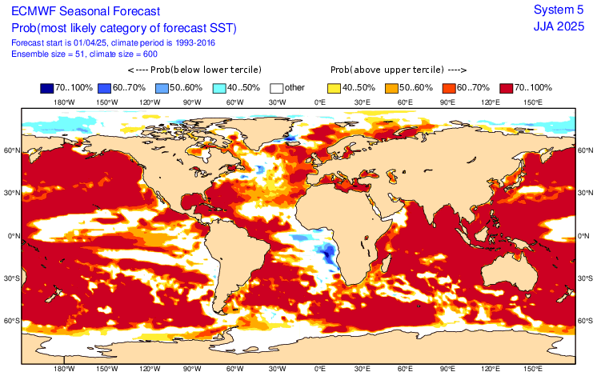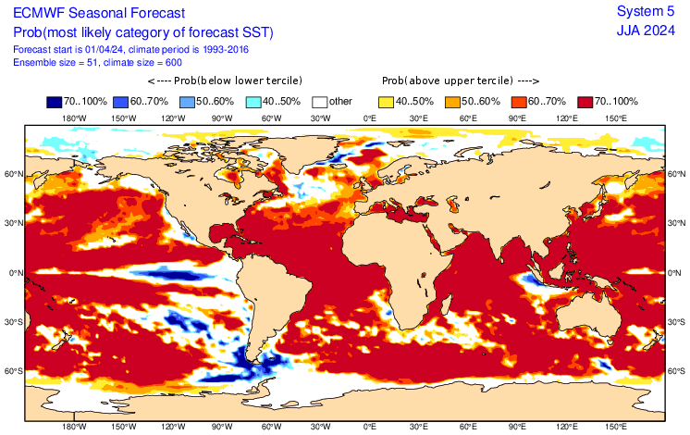

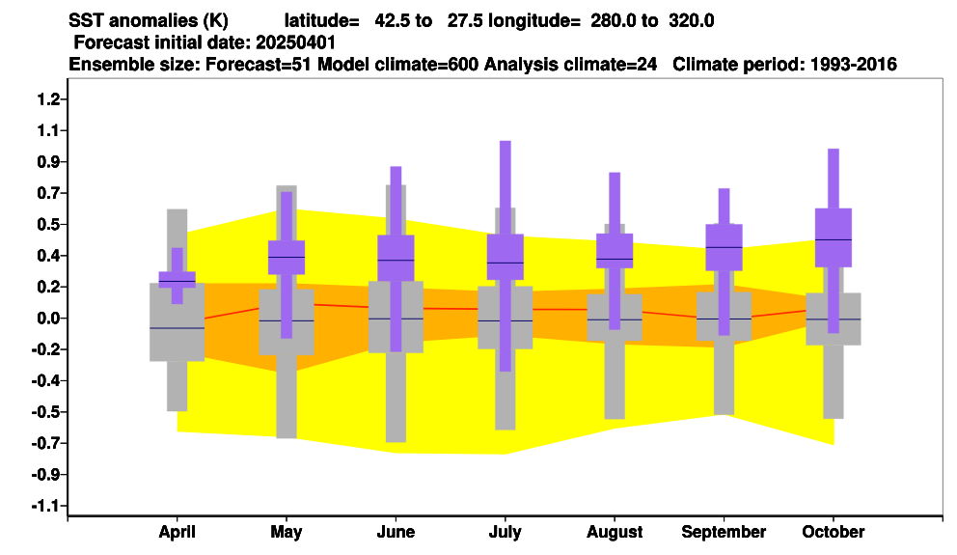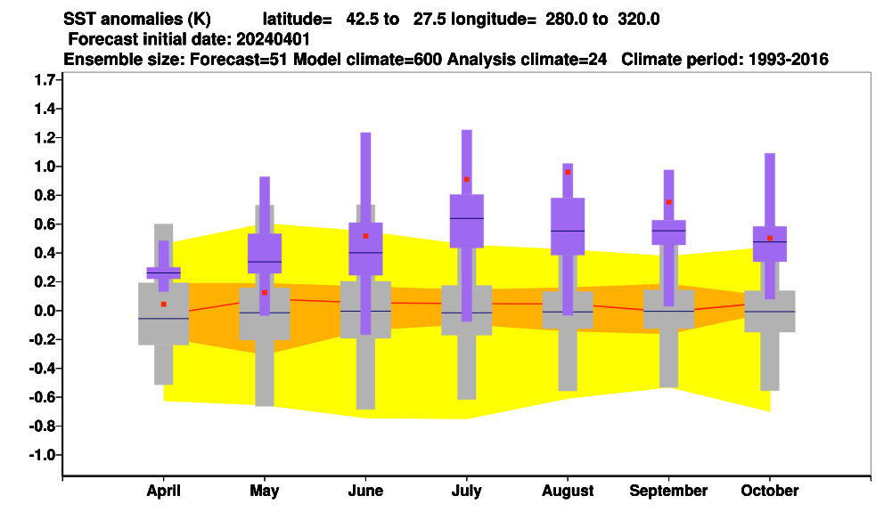

|  |  |  |  |
| --- | --- | --- | --- |
| C:\Users\Drugi\Desktop\GPS-ECMWF\April\Padavine\GPC-ECMWF-Europe-ensemble-mean-Precipitation-JJA- 01-04-2024.png | C:\Users\Drugi\Desktop\GPS-ECMWF\April\Padavine\GPC-ECMWF-Europe-prob-exceeding-median-Precipitation-JJA-01-04-2024.png | C:\Users\Drugi\Desktop\GPS-ECMWF\April\Padavine\GPC-ECMWF-Europe-tercile-summary-Precipitation-JJA-01-04-2024.png | C:\Users\Drugi\Desktop\GPS-ECMWF\April\Padavine\GPC-ECMWF-Europe-prob-for-lower-third-of-the-distribution-Precipitation-JJA-01-04-2024.png |
| C:\Users\Drugi\Desktop\April\Padavine\GPC-ECMWF-Europe-ensemble-mean-Precipitation-JJA- 01-04-2025.png | C:\Users\Drugi\Desktop\April\Padavine\GPC-ECMWF-Europe-prob-exceeding-median-Precipitation-JJA-01-04-2025.png | C:\Users\Drugi\Desktop\April\Padavine\GPC-ECMWF-Europe-tercile-summary-Precipitation-JJA-01-04-2025.png | C:\Users\Drugi\Desktop\April\Padavine\GPC-ECMWF-Europe-prob-for-lower-third-of-the-distribution-Precipitation-JJA-01-04-2025.png |

|  |  |  |  |
| --- | --- | --- | --- |
| C:\Users\Drugi\Desktop\Temperatura\GPC-Toulouse-Europe-2m-ensemble-mean-anomaly-JJA-01-04-2024.gif | C:\Users\Drugi\Desktop\Temperatura\GPC-Toulouse-Europe-normalised-season-anomaly-tercile-T2m-JJA-01-04-2024.gif |  | C:\Users\Drugi\Desktop\Temperatura\GPC-ToulouseEurope-prob-for-highest-quintile-T2m-JJA-01-04-2024.gif |
| C:\Users\Drugi\Desktop\April\Temperature\GPC-Toulouse-Europe-2m-ensemble-mean-anomaly-JJA-01-04-2025.gif | C:\Users\Drugi\Desktop\April\Temperature\GPC-Toulouse-Europe-normalised-season-anomaly-tercile-T2m-JJA-01-04-2025.gif | C:\Users\Drugi\Desktop\April\Temperature\GPC-Toulouse-Europe-2m-ensemble-mean-detrended-anomaly-JJA-01-04-2025.gif | C:\Users\Drugi\Desktop\April\Temperature\GPC-ToulouseEurope-prob-for-highest-quintile-T2m-JJA-01-04-2025.gif |

|  |  |  |  |
| --- | --- | --- | --- |
| C:\Users\Drugi\Desktop\Padavine\GPC-Toulouse-Europe-Precipitation-ensemble-mean-JJA-01-04-2024.gif | C:\Users\Drugi\Desktop\Padavine\GPC-Toulouse-Europe-Precipitation-ensemble-mean-normalised-anomaly-JJA-01-04-2024.gif | C:\Users\Drugi\Desktop\Padavine\GPC-Toulouse-Europe-Precipitation-ensemble-mean-deterended-anomaly-JJA-01-04-2024.gif |  |
| C:\Users\Drugi\Desktop\April\Precipitation\GPC-Toulouse-Europe-Precipitation-ensemble-mean-JJA-01-04-2025.gif | C:\Users\Drugi\Desktop\April\Precipitation\GPC-Toulouse-Europe-Precipitation-ensemble-mean-normalised-anomaly-JJA-01-04-2025.gif | C:\Users\Drugi\Desktop\April\Precipitation\GPC-Toulouse-Europe-Precipitation-ensemble-mean-deterended-anomaly-JJA-01-04-2025.gif | C:\Users\Drugi\Desktop\April\Precipitation\GPC-Toulouse-Europe-Precipitation-prob-for-lowest-quintile-JJA-01-04-2025.gif |

|  |  |  |  |
| --- | --- | --- | --- |
| JJA 2024 | JJA 2024 | JJA 2024 | JJA 2024 |
| JJA 2025 | JJA 2025 | JJA 2025 | JJA 2025 |

|  |  |  |  |
| --- | --- | --- | --- |
| JJA 2024 | JJA 2024 | JJA 2024 | JJA 2024 |
| JJA 2025 | JJA 2025 | JJA 2025 | JJA 2025 |