CLIMATE OUTLOOK FOR THE 2025 SUMMER SEASON FOR SERBIA
AND THE SEECOF REGION

April 29th, 2025

INTRODUCTION

NHMS of Serbia regularly prepares climate outlook for our country based both the ECMWF seasonal forecast model outputs, and the SEEVCCC regional climate model outputs. This paper provides an extended climate outlook for summer season for the entire SEECOF region not only Serbia.

CLIMATE OUTLOOK FOR THE 2025 SUMMER SEASON BASED ON ECMWF SEASONAL FORECAST MODEL OUTPUTS FOR SERBIA AND THE SEE REGION
(Hindcast period 1993-2016)

Entire Serbia is likely to experience above-normal summer temperature. Northern parts of the country are likely to observe above-normal summer precipitations sums, elsewhere, there is no predictive signal. Consequently, warmer than average summer is forecast for most of Serbia while in the northern parts of the country, summer is likely to be warmer and wetter compared to the average.

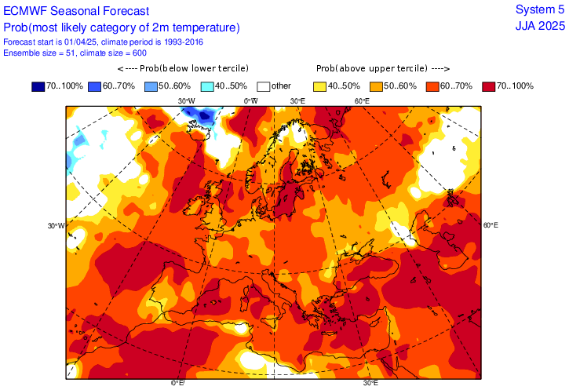 | 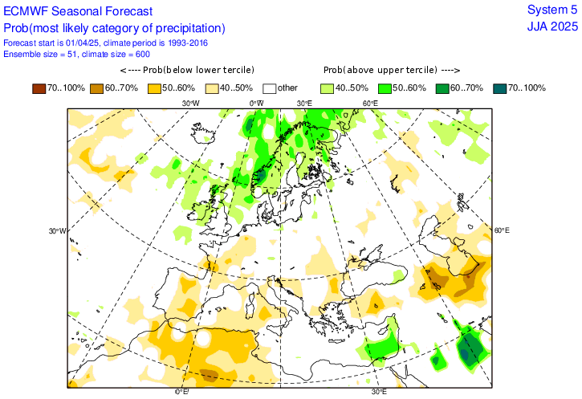

In almost the entire SEECOF region, summer temperature is likely to be above-normal, with the probability decreasing from the Carpathian region, Adriatic, Ionian, Aegean and Mediterranean Sea, continental parts of Turkey and South Caucasus region towards Black Sea with belonging coasts. There is no predictive signal in the eastern and southern parts of Ukraine.

In the Pannonia Plain, southern parts of Balkan Peninsula, along the Adriatic, Aegean and Mediterranean Seas with belonging coasts, southern parts of Turkey, Israel, Lebanon and Syria summer precipitation totals are likely to be above-normal. In remainder of the SEECOF region, there is equal probability for below, near-normal or above-normal conditions.

CLIMATE OUTLOOK FOR THE 2025 SUMMER SEASON BASED ON COPERNICUS SEASONAL FORECAST MODEL OUTPUTS FOR SERBIA AND THE SEE REGION
(Hindcast period 1993-2016)

Summer temperature in Serbia is likely to be above-normal. Eastern parts of the country are likely to record above-normal summer precipitations sums. In remainder of the country there is no predictive signal for summer precipitation sums. Consequently, most of Serbia will observe a warmer than average summer, while in the eastern parts of the country, summer is likely to be warmer and wetter compared to the average.

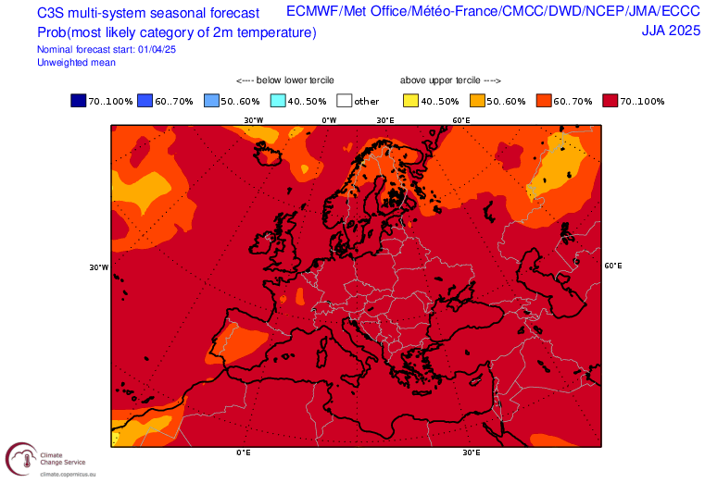 | 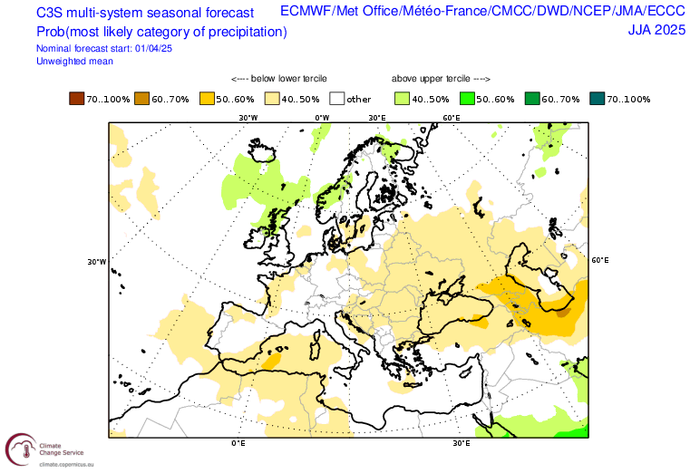

In almost the entire SEECOF region, summer temperature is likely to be above-normal, with the probability decreasing from the Adriatic, Ionian, Aegean and Mediterranean Sea, continental parts of Turkey and South Caucasus region towards north and northeast of the SEECOF region.

In the central and eastern parts of Turkey, central and southern parts of Balkan Peninsula, along the Mediterranean and southern parts of Aegean Sea with belonging coasts, as well as in mountainous parts of the South Caucasus region summer precipitation totals are likely to be above-normal, while in rest of the SEECOF region, there is equal probability for below, near-normal or above-normal conditions.

SUGGESTED NHMS SERBIA - CLIMATE OUTLOOK FOR THE 2025 SUMMER SEASON FOR SERBIA AND THE SEE REGION

Summer temperature in Serbia is likely to be above-normal, with equal probabilities for below-, near- or above-normal summer precipitation sums. Consequently, climate conditions warmer than average are anticipated in the entire country.

Graphical presentation of the 2025 summer temperature outlook | Graphical presentation of the 2025 summer precipitation outlook

In the entire SEECOF region, summer temperature is likely to be above-normal, with the probability increasing from the north-eastern (Zone 2 in Figure 1) towards south and south-western regions (Zone 1 in Figure 1).

Uncertainties in regional predictions are higher for precipitation than for temperature. Southern parts of Ukraine and Greece, Turkey, as well as the coasts of Black Sea are likely to experience near- or above-normal conditions in terms of summer precipitation sums (Zone 2 in Figure 2) while in most of the SEECOF region there is equal probability for summer precipitation (Zone 1 in Figure 2). It is noteworthy that certain parts of the country, particularly mountainous regions, might observe near- or above-normal summer precipitation totals due to the episodes of enhanced convection accompanied by heavy precipitation. Due to dry season masking, it is not possible to forecast summer precipitation totals along the eastern coasts of the Eastern Mediterranean, Crete, Israel and Jordan.

